CHECKLIST

**Perceivable**

Ensures that content is presented in ways that users can perceive.

Text Alternatives (1.1):

Provide text alternatives for all non-text content.

* Amend it by putting alt tags on all images.

Time-Based Media (1.2):

Provide captions and text alternatives for audio and video content.

* We use the <track> element for captions and provide a text alternative within the <video> element itself.

Adaptable (1.3):

Ensure content can be presented in different ways without losing information or structure.

Tools: Web Accessibility Evaluation Tools, Acrobat Pro DC Accessibility Checker.

* Adding title (cannot be blank).
* img elements must have an accessible name.

Distinguishable (1.4):

Make it easier for users to see and hear content, including separating foreground from background.

Tools: Colour Contrast Analyser, ZoomText Magnifier/Reader, Microsoft Magnifier.

**Operable**

Ensures that interface and navigation are operable by all users.

Keyboard Accessible (2.1):

Ensure all functionality is available from a keyboard.

Tools: Keyboard navigation tests.

Enough Time (2.2):

Provide users enough time to read and use content.

Tools: Tests for stopping, starting, and pausing content.

Seizures and Physical Reactions (2.3):

Do not design content in a way that is known to cause seizures.

Tools: Automated testing tools to identify seizure risks.

Navigable (2.4):

Provide ways to help users navigate, find content, and determine where they are.

Tools: Focus frame tests, navigation tools.

**Understandable**

Ensures that content is readable and understandable.

Readable (3.1):

Make text content readable and understandable.

Tools: Flesch Kincaid Calculator, readability statistics tools.

* <https://serpninja.io/tools/flesch-kincaid-calculator/>

Used this toll to calculate.

Predictable (3.2):

Make web pages appear and operate in predictable ways.

Ensure consistent navigation and identical functioning elements.

Input Assistance (3.3):

Help users avoid and correct mistakes.

Provide feedback for user inputs and ensure reversibility.

**Robust**

Ensures that content is robust enough to work with current and future technologies, including assistive technologies.

Compatible (4.1):

Maximize compatibility with current and future user agents, including assistive technologies.

Tools: SCORM Explained, testing with assistive technologies like Jaws or Dragon.

WAI Conformance Level AA standard

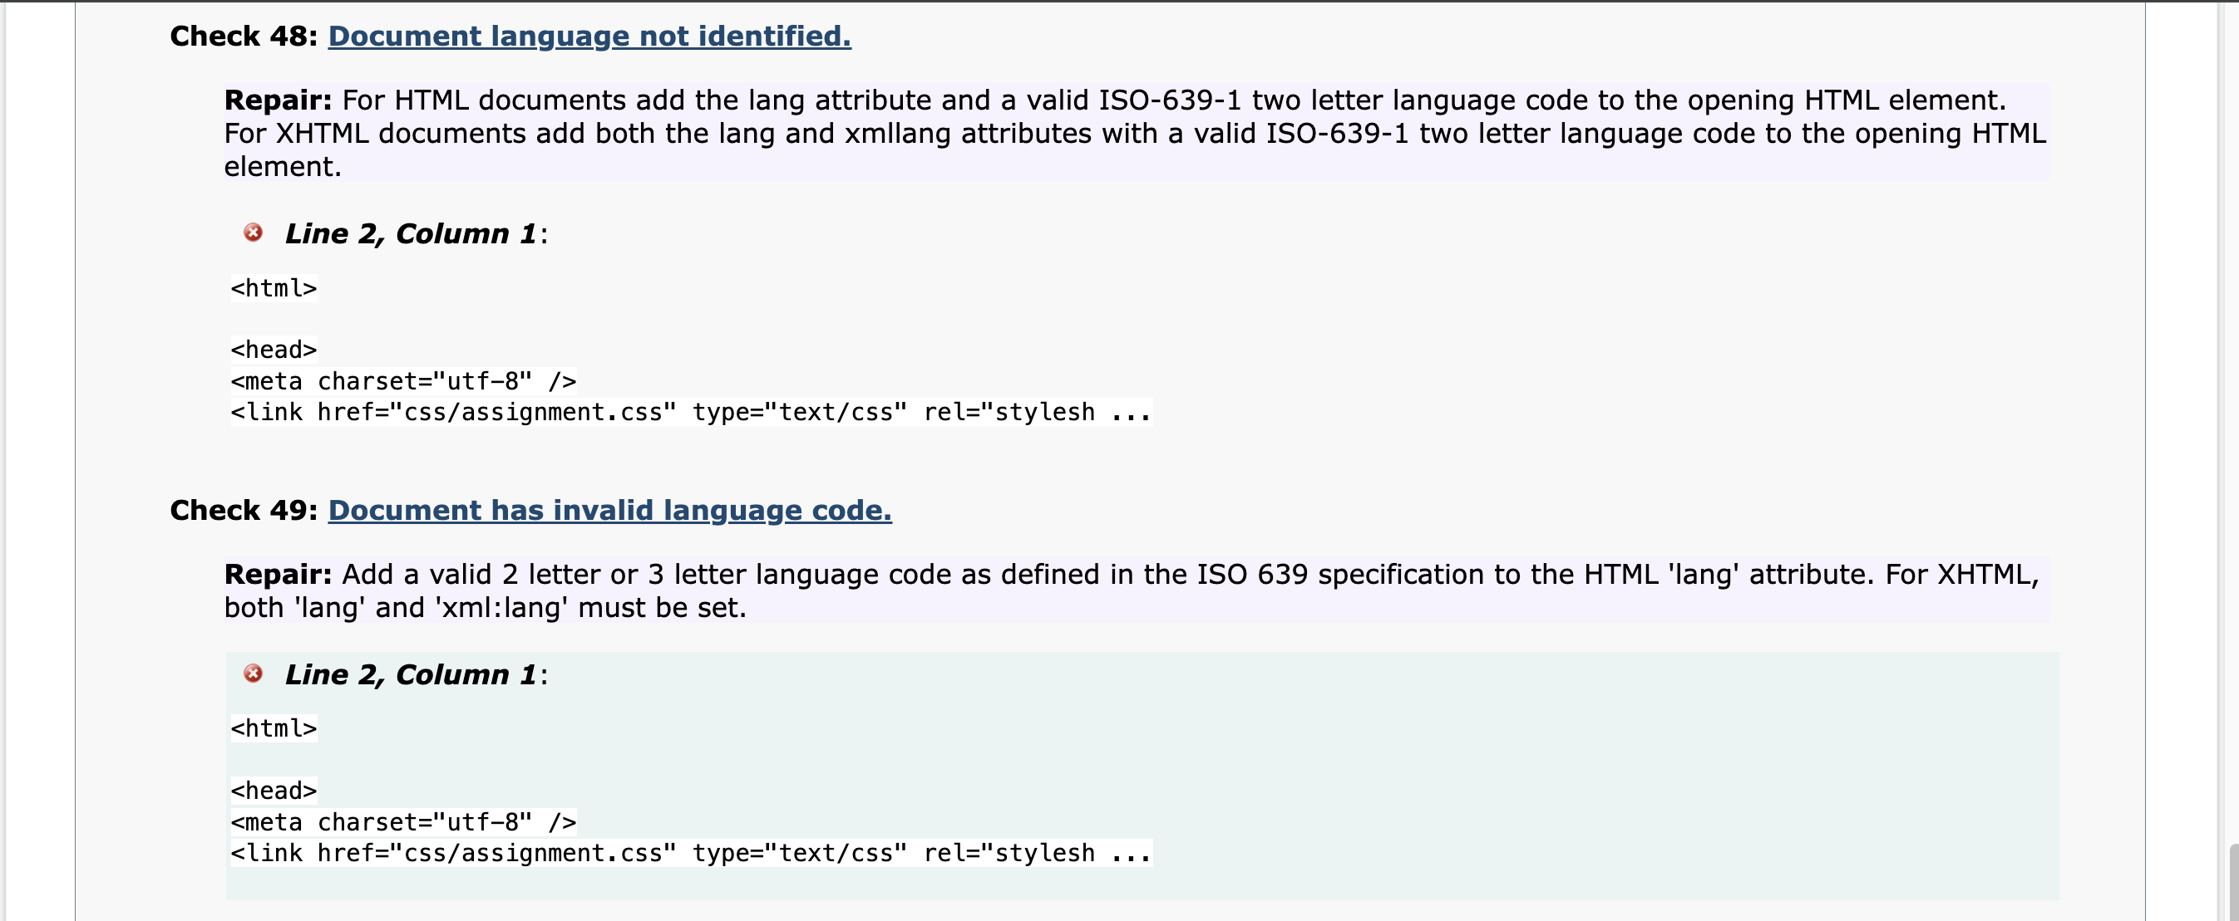

Validator

Accessibility Checker

